**Project Design Phase-I Solution Architecture**

|  |  |
| --- | --- |
| Date | 31.10. 2023 |
| Team ID | NM2023TMID03286 |
| Project Name | Blockchain Technology For Electronic Health Records |
| Maximum Marks | 4 Marks |

**Solution Architecture:**

Core Features of Customer App

Searching menu: Allow your users to search for different restaurants, cafes by location, and cuisines. Using the search filter, users can easily find their favorite eating places, list menu, offers, etc.

Order placement: The user can place an order of selected dishes and food. They just need to cross-verify their preferred dish, delivery time, and proceed check-out.

Tracking Delivery Partners: With real-time tracking features, it becomes easy for users to track delivery drivers and know their real-time location information. Users can check the time taken by the food delivery executive to deliver their parcel.

Payment gateway integration: You provide the users with multiple payment options like credit/debit cards, different wallets like Google Pay, Paytm, Phonepe, UPI, etc

Core Features of Delivery Partner

Delivery Partner’s profile: Through this feature, a driver can keep his profile update. It contains his full name, address, email, contact number, photo, and other personal information.

Notification for orders: Through push notifications, drivers can get constant updates & alerts for new orders. It will help in the accurate delivery service of your restaurant.

Map for the delivery route: Integrate Google Map or other providers and allow drivers to choose the shortest and fastest routes to reach the location.

Core Features of Food Partners/ Restaurants

Restaurant Profile/Menu: Through this feature, a restaurant owner can add their restaurant details, menu and its availability, price, preparation times, etc

Notification for orders: Through push notifications, Restaurants can get constant updates

& alerts for new orders. It will help in the accurate delivery service of your restaurant. Notifications for Pickup Partners: They will get alerts about delivery partners, their location when they will pick up, etc.

Payment Details: Information about the payment received from the food delivery system for their orders

Core Features for Food Ordering System Admin

Restaurant management: Being on the admin panel, one can directly manage all the restaurants by adding, updating, and removing any eating joint from the list. He can also check active restaurant status.

Analytics & report generation: Using analysis and report features, you can get real-time insights of reports and other accounting information which helps you to identify the growth and opportunities to expand reach.

Monitoring every action: Monitor all the food orders, delivery partners, deliveries, reviews & ratings of delivery partners, canceled orders, and other important data related to the driver’s performance.

Application Flow

We are considering here microservices-based architecture. Different services are listed in the architecture diagram

**Example - Solution Architecture Diagram:**

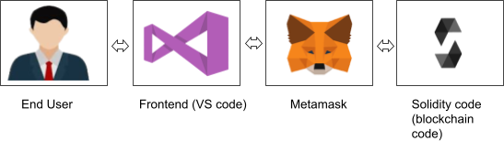

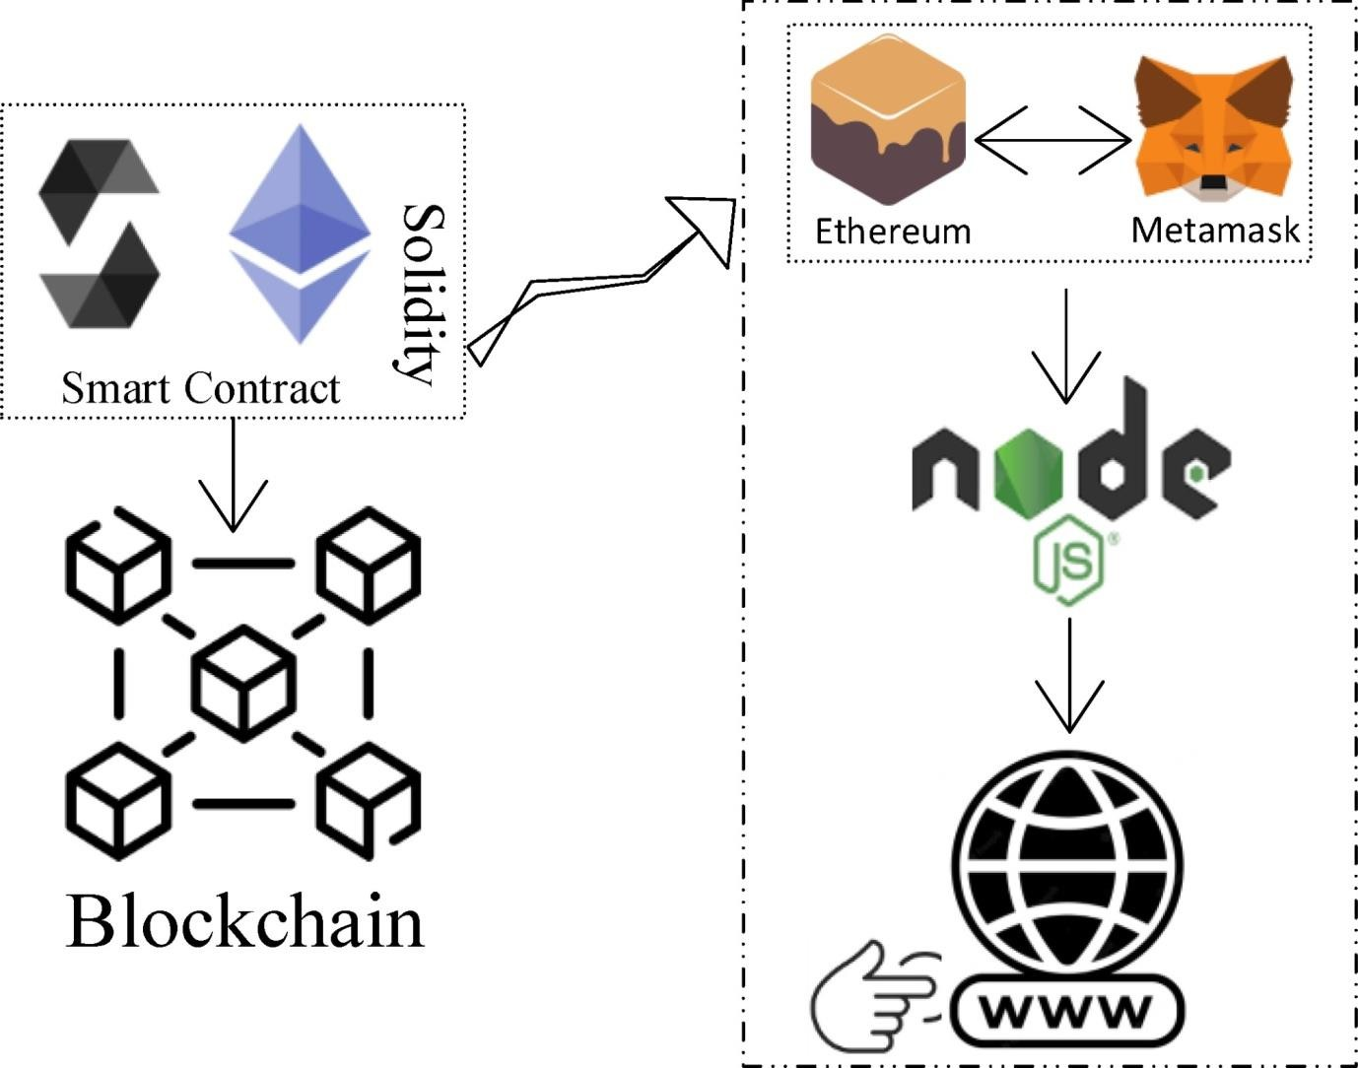

**Steps to complete the project**

